Linear functions

Functions of the form y=mx+c are called straight line functions. In the equation, y=mx+c, m and c are constants and have different effects on the graph of the function.
Domain: These are the x input values that are substituted into the function.
Range: These are the y output values that are substituting into the function.

Example 1: Given that $y=x$
- Complete the table below:

x | -2 | -1 | 0 | 1 | 2
y | -2 | -1 | 0 | 1 | 2

- Join the points on the Cartesian points.
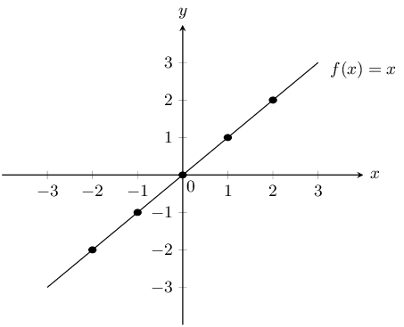
- Determine the domain and the range of the function.
Domain: $∞<$ X $>∞$ or X$∈$IR
Range: $∞<$y $>∞$ or y$∈$ IR

EXERCISE 2
Given that $y=x+2$
- Complete the table below:

x | -2 | -1 | 0 | 1 | 2
y

- Join the points on the Cartesian Plane.

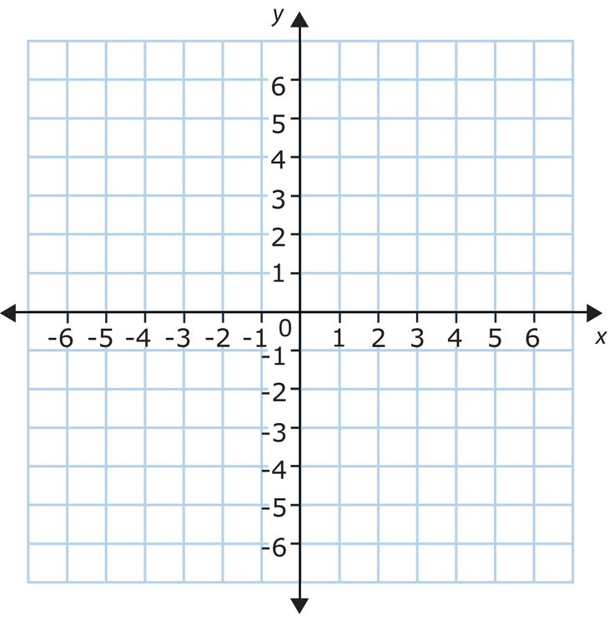

- Write down the domain and range of the function.

